Lot # 22295642 - 2009 JAGUAR XF PREMIUM

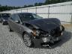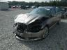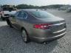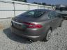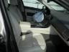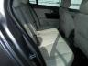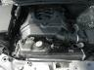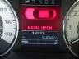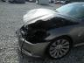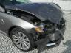

Lot Details Highlights  ACV: $34 911 USD  Repair Cost: $23 405 USD  Title State/Type: GA CERT OF TITLE-SALVAGE  Odometer: 19 588 ACTUAL  Primary Damage: FRONT END  Secondary Damage:  VIN: SAJWA06B59HR31593  Body Style: SEDAN 4DR  Color: GRAY  Engine: 4.2L 8  Drive: REAR-WHEEL DRIVE  Cylinders: 8  Fuel: GAS  Keys: YES  Special Note:  Services | Bid Information  Facility: GA - ATLANTA SOUTH  Sale Date: 10/30/12  Sale Time: 12:00 PM EDT  Item # / Grid/Row: 3091 / SA002

